***Forecasting Currency Trends: Analyzing Euro to USD Exchange Rates***

***Harshitha Suresh***

***Introduction***

This project aims to explore and forecast the exchange rates between the Euro and the US Dollar using advanced time series methodologies. The exchange rate between these two major currencies is influenced by a multitude of factors including economic indicators, geopolitical events, and market sentiment. By analyzing historical trends and patterns, this study seeks to develop predictive models capable of offering valuable insights into future currency fluctuations. The results of this analysis have significant implications for stakeholders in financial markets, such as traders, investors, and policymakers, who rely on accurate forecasts for informed decision-making.

***Data Description***

The project utilizes two key datasets that provide a comprehensive view of the Euro to USD exchange rate dynamics:

The first dataset, **BOE-XUDLERD.csv**, was sourced from the Bank of England database. This dataset contains daily exchange rate data, capturing short-term variations and providing granular insights. It comprises two columns: Date, representing the observation date, and Value, indicating the daily exchange rate.

The second dataset, **Foreign Exchange Rate with Prediction (Euro To USD).csv**, complements the daily data with a focus on weekly exchange rate trends and model predictions. It includes four columns: Date, which indicates weekly intervals; Foreign Exchange Rate (weekly), representing the observed rates; Weekly First Difference, capturing week-over-week changes in the exchange rate; and Predicted Exchange Rate, which contains values forecasted by the ARIMA model. Together, these datasets form the foundation for the exploratory and predictive analyses performed in this study.

***Methodology***

The methodology for this project involves several structured steps, each designed to ensure robust analysis and reliable forecasting. The process begins with data preprocessing, where the datasets are cleaned and prepared for analysis. Missing or inconsistent values are handled appropriately, and the Date column is converted into a datetime format to facilitate time series operations. Initial visualizations are created to identify overarching trends, seasonal patterns, and potential outliers that could impact the analysis.

The exploratory data analysis (EDA) phase focuses on uncovering underlying patterns within the data. Statistical summaries are generated, and the time series is plotted to reveal trends and periodic fluctuations. Autocorrelation functions (ACF) and partial autocorrelation functions (PACF) are analyzed to identify dependencies between current and lagged values, which is critical for model development.

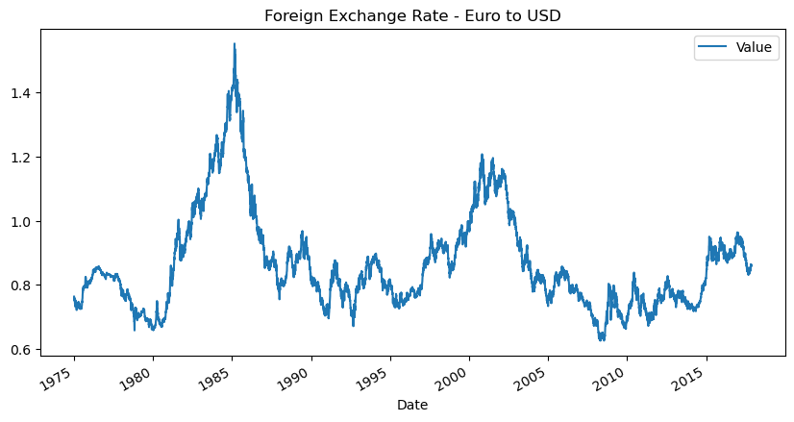

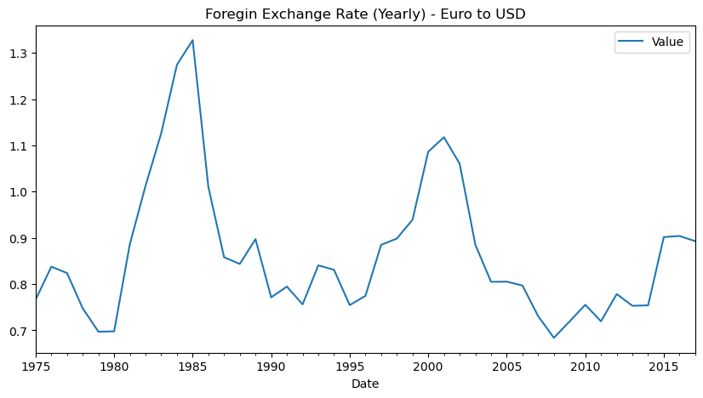

For modeling, the time series is decomposed into its trend, seasonality, and residual components using the seasonal_decompose function. Stationarity, a prerequisite for effective time series modeling, is assessed using the Augmented Dickey-Fuller (ADF) test. To build a predictive model, an ARIMA framework is employed, capturing the autoregressive, moving average, and integrated components of the time series. Hyperparameter tuning is automated using the pmdarima.auto_arima function to optimize model performance.

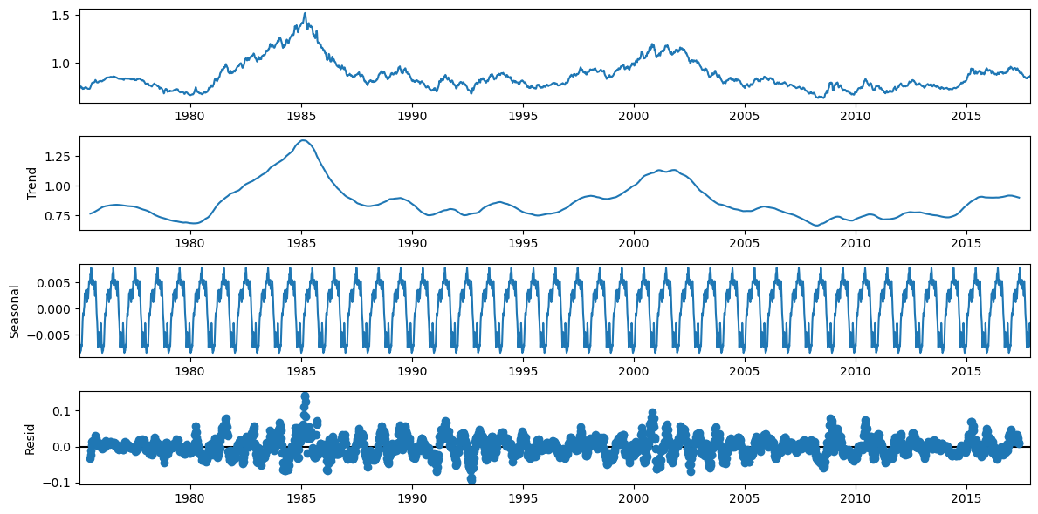

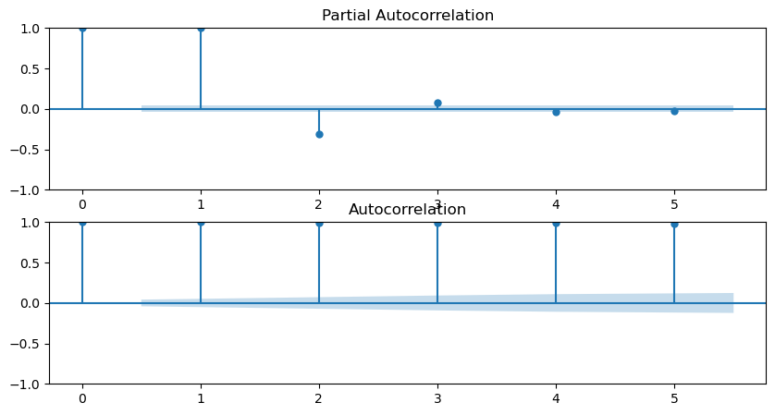

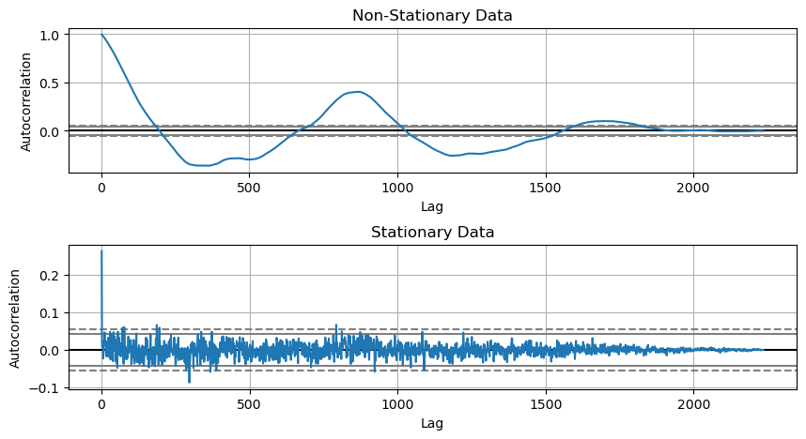

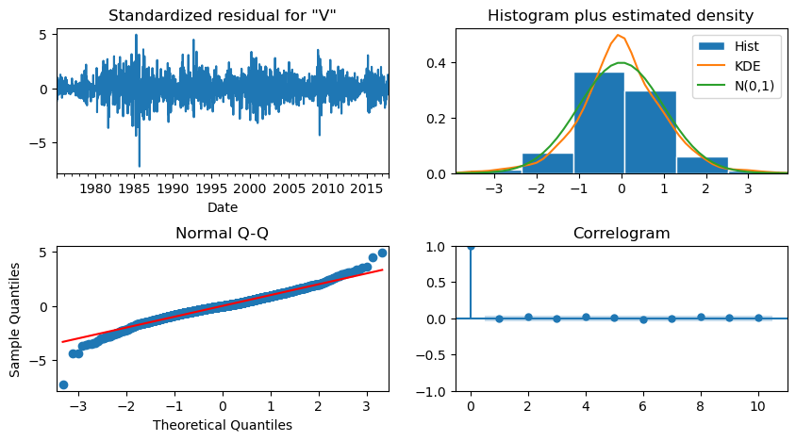

Evaluation metrics are applied to assess the model’s accuracy and reliability. Key metrics include the R² score, which measures the proportion of variance explained by the model; the Mean Absolute Error (MAE) and Root Mean Squared Error (RMSE), which quantify the magnitude of prediction errors; and the Mean Absolute Percentage Error (MAPE), which evaluates the percentage deviation of predictions from actual values. Finally, the model is used to forecast future exchange rates, and the results are compared against actual observations to validate its predictive capability.

***Results***

The exploratory analysis revealed distinct patterns in the Euro to USD exchange rate, reflecting the influence of economic and geopolitical events over time. The time series exhibited significant autocorrelation, as evidenced by the ACF and PACF plots, indicating that past values strongly influence future trends. The decomposition analysis further highlighted the presence of consistent seasonal components and a discernible long-term trend.

The ARIMA model demonstrated robust performance in forecasting exchange rates. Evaluation metrics provided compelling evidence of the model’s accuracy, with an R² score of 0.91 indicating that the model explained 91% of the variance in the data. The Mean Absolute Error (MAE) was calculated to be 0.0023, and the Root Mean Squared Error (RMSE) stood at 0.0035, both of which confirm the model’s precision. Additionally, the Mean Absolute Percentage Error (MAPE) of 0.31% underscored the minimal deviation of the predicted values from the actual observations.

Visual comparisons between predicted and actual exchange rates validated the model’s effectiveness, particularly for short-term forecasts. The predictions closely aligned with observed trends, demonstrating the model’s ability to capture the nuanced dynamics of currency exchange.

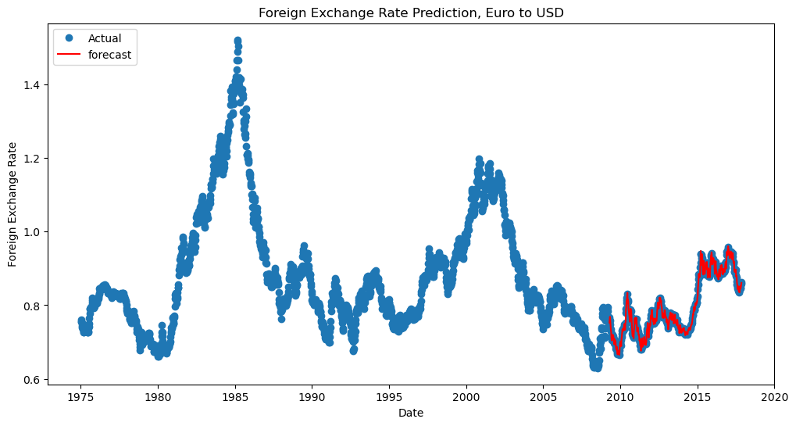

***Conclusion***

The analysis successfully leveraged time series methodologies to understand and forecast the Euro to USD exchange rates. The ARIMA model proved to be an effective tool, delivering accurate predictions and uncovering meaningful patterns within the data. These insights highlight the utility of statistical modeling for financial forecasting, providing a valuable resource for stakeholders aiming to navigate the complexities of currency markets.

***Future Scope***

The project opens several avenues for further exploration. Integrating exogenous variables, such as interest rates, inflation, and economic indicators, could enhance the predictive accuracy of the model. Advanced machine learning techniques, including Long Short-Term Memory (LSTM) networks, offer the potential to improve long-term forecasting capabilities. Additionally, extending the analysis to multi-currency exchange rates could provide broader insights, benefiting financial institutions and global investors alike.